**GRAVITATION**

**Definition** : The force of attraction between any two particles in the universe Is called **gravitation** or **gravitational force**.

Newton gave *Newton’s law of gravitation* to calculate gravitational force between two objects placed at certain distance from each other.

**KEPLER’S LAWS OF PLANETARY MOTION**

**Kepler’s laws**. Johannes Kepler gave the following three laws to explain the motion of the planets.

1. **Law of Orbits :** Each planet moves around the sun in an elliptical orbit with the sun at one of the foci* of the orbit.
2. **Law of areas :** The line joining the sun and a planet sweeps out equal areas in equal intervals of time.
3. **Law of Periods :** The square of the time taken by a planet to complete a revolution round the sun is directly proportional to the cube of semi-major axis of the elliptical orbit.

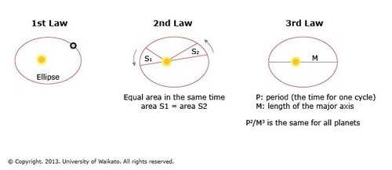i.e T2 r3